Software development

<https://thenewstack.io/software-development/>

Tab 1 Introduction

Software development



Software development is a field that involves processes, methods and practices in creating, designing, deploying and maintaining software applications and systems. At its essence software development aims to meet user requirements and business goals through the development of software.

The history of software creation dates back to the mid-20th century. Has evolved significantly from programming to the complex and diverse field it is today. Initially, software development was closely tied to the hardware it operated on involving programming in machine language. The introduction of high-level programming languages such as [FORTRAN](https://thenewstack.io/how-john-backus-fortran-beat-machine-codes-priesthood/) and [COBOL](https://thenewstack.io/going-from-cobol-to-cloud-native/) in the 1950s and 1960s brought about a shift towards efficient coding practices.

Tab 2 Process

The Sd Process



The software development process, or the Software Development Life Cycle (SDLC), is a structured sequence of stages that guide the creation of a software product. This life cycle provides a framework for planning, creating, testing, and deploying software, ensuring quality and functionality meet user demands and business objectives. Understanding the SDLC and its phases is fundamental for software developers and project managers to navigate the complexities of software creation efficiently.

The software development process, or the Software Development Life Cycle (SDLC), is a structured sequence of stages that guide the creation of a software product. This life cycle provides a framework for planning, creating, testing, and deploying software, ensuring quality and functionality meet user demands and business objectives. Understanding the SDLC and its phases is fundamental for software developers and project managers to navigate the complexities of software creation efficiently.

Tab 3 Roles

Roles in Software Development

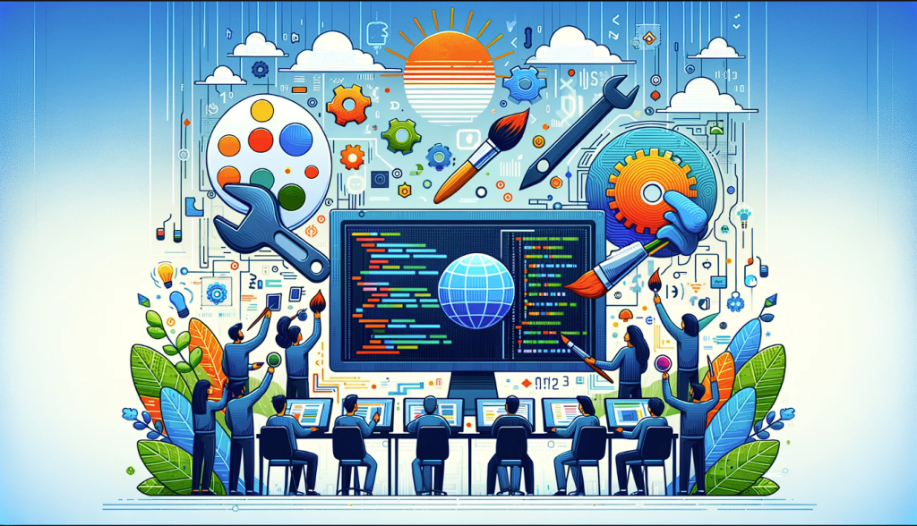

In the world of software development, various roles contribute to the creation, testing and maintenance of software. Each role brings skills and responsibilities that work together to ensure the progress of software programs and systems. Understanding these roles such as software developer, systems software developer, software engineer or quality analyst is crucial, for individuals involved in or exploring the field of software development.